**chapter 3**

**3.1.3.2 Exercises**

1. Inspect your bash history and use history expansion to re-run a command from it.

use history

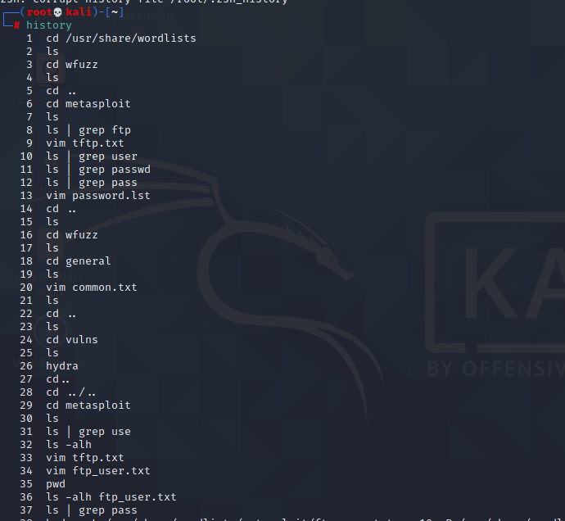

and select command

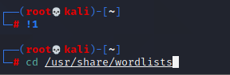

2. Execute different commands of your choice and experiment browsing the history through

the shortcuts as well as the reverse-i-search facility.

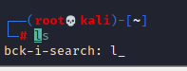

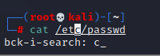

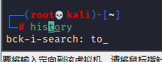

**3.2.5.1 Exercises**

1. Use the cat command in conjunction with sort to reorder the content of the /etc/passwd

file on your Kali Linux system.

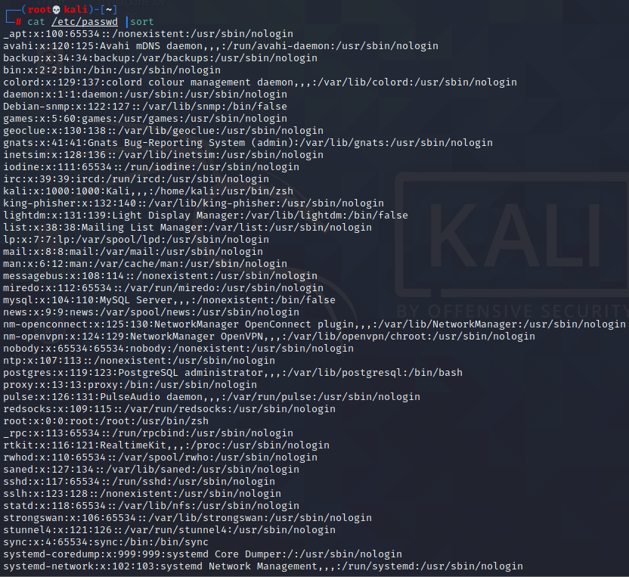

1. Redirect the output of the previous exercise to a file of your choice in your home directory.

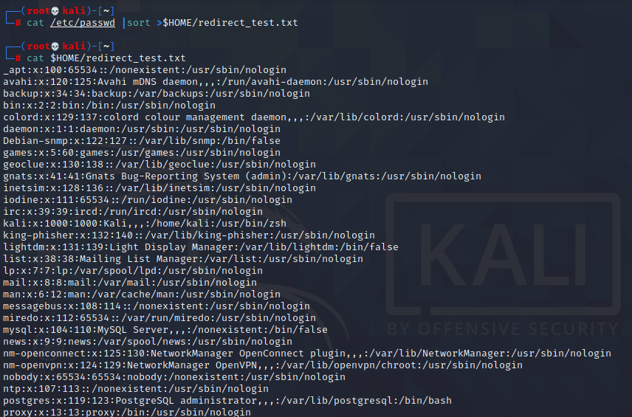

**3.3.5.1 Exercises**

1. Using /etc/passwd , extract the user and home directory fields for all users on your Kali

machine for which the shell is set to /bin/false. Make sure you use a Bash one-liner to print

the output to the screen. The output should look similar to Listing 53 below:

kali@kali:~$ YOUR COMMAND HERE...

The user mysql home directory is /nonexistent

The user Debian-snmp home directory is /var/lib/snmp

The user speech-dispatcher home directory is /var/run/speech-dispatcher

The user Debian-gdm home directory is /var/lib/gdm3

Listing 53 - Home directories for users with /bin/false shells

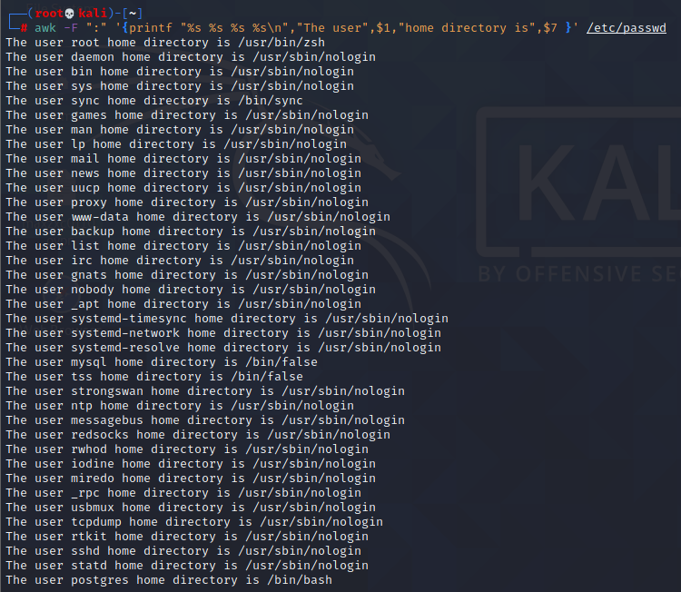

1. Copy the /etc/passwd file to your home directory ( /home/kali ).

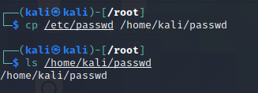

3. Use cat in a one-liner to print the output of the /kali/passwd and replace all instances of the

“Gnome Display Manager” string with “GDM”.

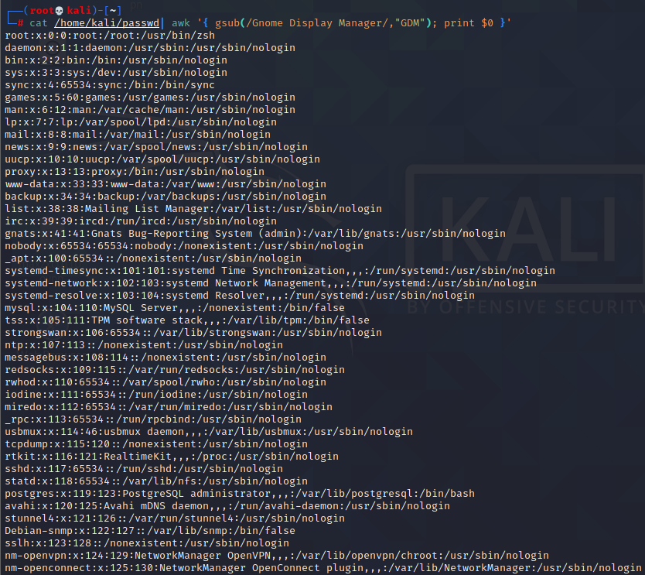

**3.5.3.1 Exercises**

1. Download the archive from the following URL https://offensive-security.com/pwk-

files/scans.tar.gz

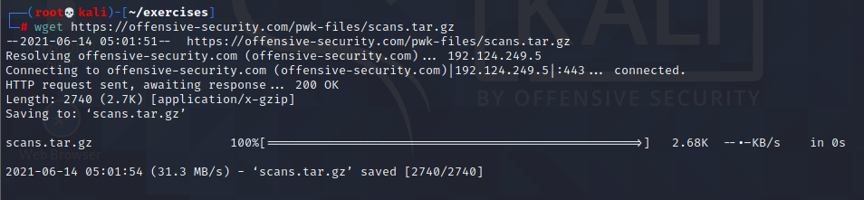

2. This archive contains the results of scanning the same target machine at different times.

Extract the archive and see if you can spot the differences by diffing the scans.

use diff

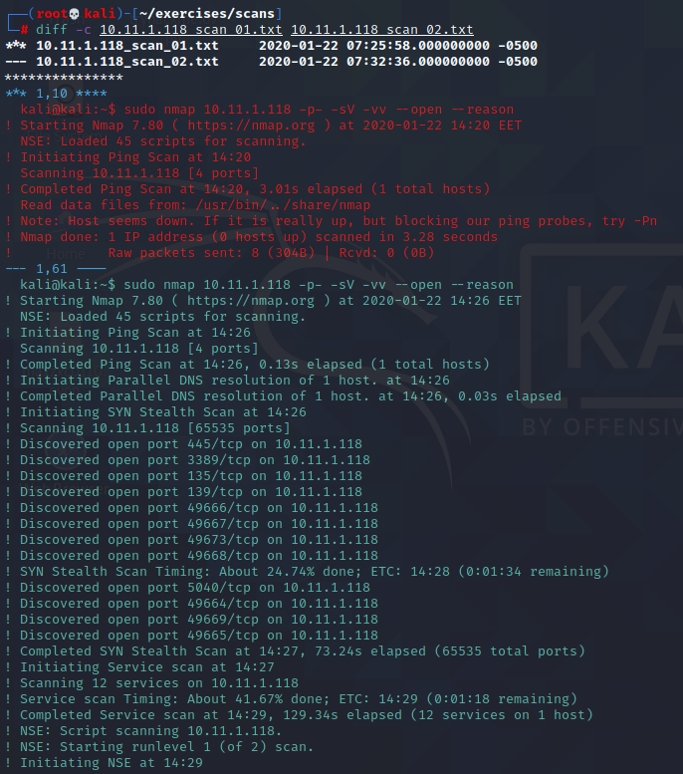

use vimdiff

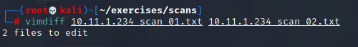

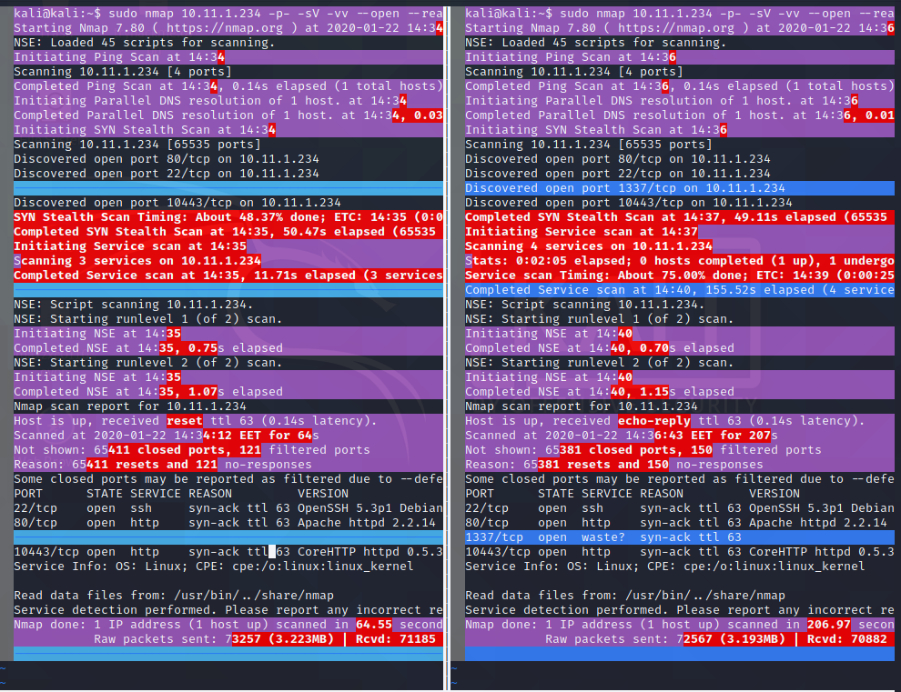

use comm

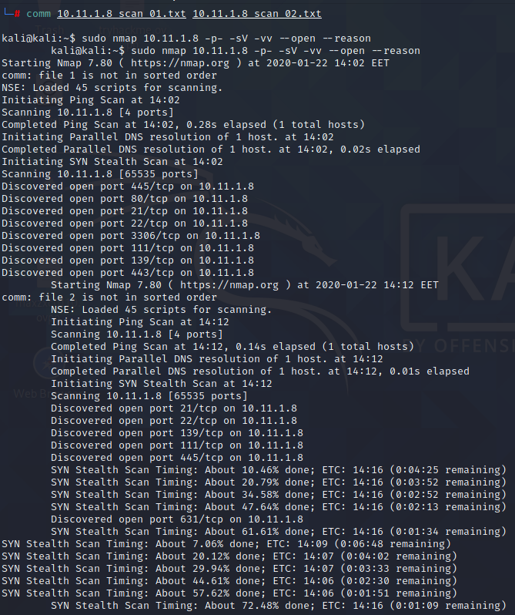

**3.6.3.1 Exercises**

1. Find files that have changed on your Kali virtual machine within the past 7 days by running a

specific command in the background.

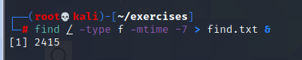

1. Re-run the previous command and suspend it; once suspended, background it.

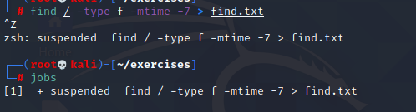

1. Bring the previous background job into the foreground.

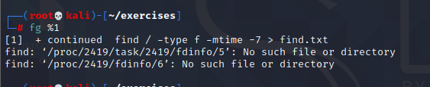

1. Start the Firefox browser on your Kali system. Use ps and grep to identify Firefox’s PID.



1. Terminate Firefox from the command line using its PID.

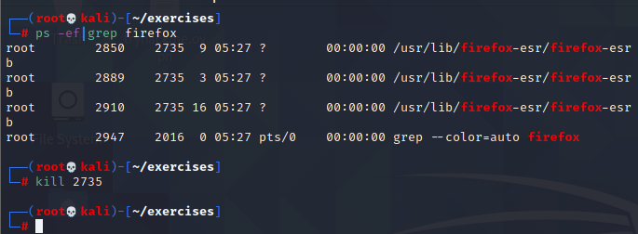

**3.7.2.1 Exercises**

1. Start your apache2 web service and access it locally while monitoring its access.log file in

real-time.

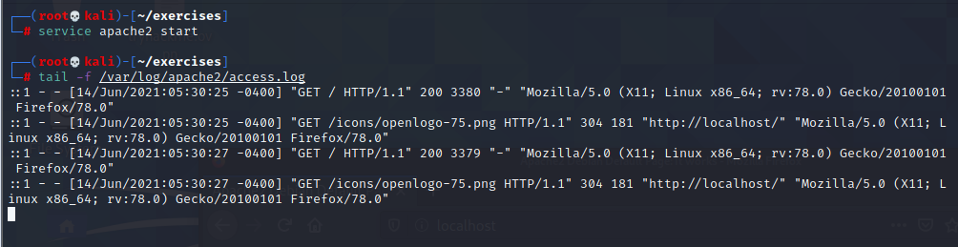

2. Use a combination of watch and ps to monitor the most CPU-intensive processes on your

Kali machine in a terminal window; launch different applications to see how the list changes

in real time.



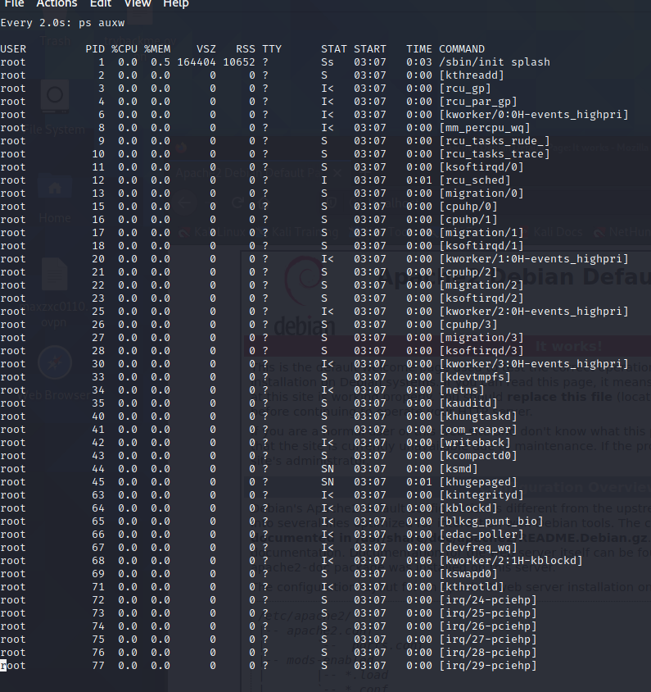

**3.8.3.1 Exercise**

1. Download the PoC code for an exploit from https://www.exploit-db.com using curl , wget ,

and axel , saving each download with a different name.

wget

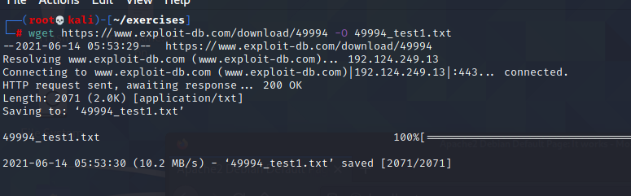

curl

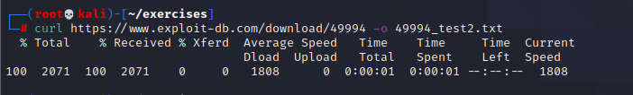

axel

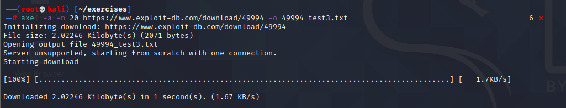

**3.9.3.1 Exercises**

1. Create an alias named “..” to change to the parent directory and make it persistent across

terminal sessions.

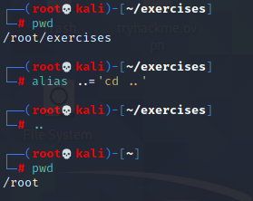

2. Permanently configure the history command to store 10000 entries and include the full date

in its output.

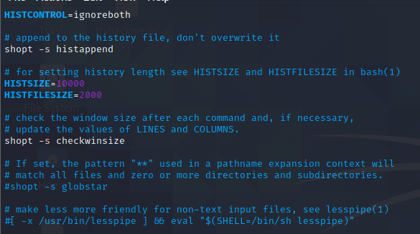

chapter 4

4.2.4.1 Exercises

1. Use socat to transfer powercat.ps1 from your Kali machine to your Windows system. Keep

the file on your system for use in the next section.

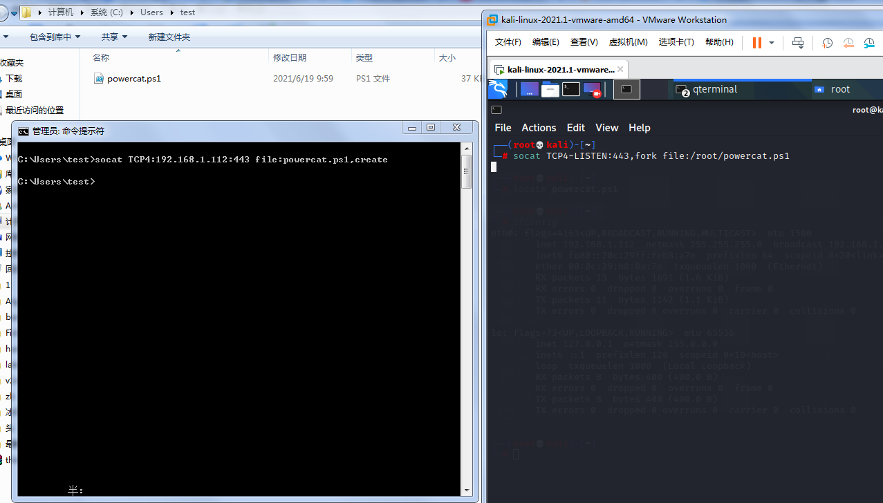

2. Use socat to create an encrypted reverse shell from your Windows system to your Kali

machine.

3. Create an encrypted bind shell on your Windows system. Try to connect to it from Kali

without encryption. Does it still work?

4. Make an unencrypted socat bind shell on your Windows system. Connect to the shell using

Netcat. Does it work?

Yes

On windows,we input the command: socat -d -d TCP4-LISTEN:4443 EXEC:'cmd.exe',pipes

On kali,we use netcat to connect it:nc -nv 192.168.1.102 4443

then done.

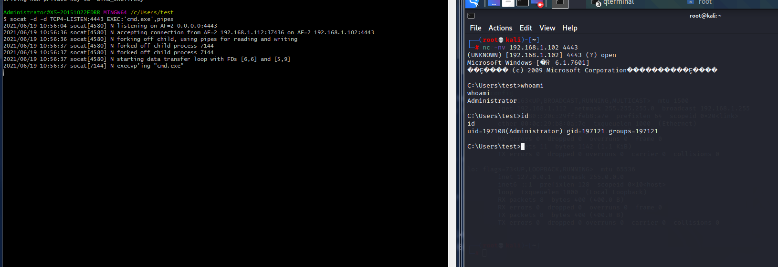

4.3.8.1 Exercises

1. Use PowerShell and powercat to create a reverse shell from your Windows system to your

Kali machine.

2. Use PowerShell and powercat to create a bind shell on your Windows system and connect

to it from your Kali machine. Can you also use powercat to connect to it locally?

3. Use powercat to generate an encoded payload and then have it executed through

powershell . Have a reverse shell sent to your Kali machine, also create an encoded bind

shell on your Windows system and use your Kali machine to connect to it.

4.4.5.1 Exercises

1. Use Wireshark to capture network activity while attempting to connect to 10.11.1.217 on

port 110 using Netcat, and then attempt to log into it.

2. Read and understand the output. Where is the three-way handshake happening? Where is

the connection closed?

3. Follow the TCP stream to read the login attempt.

4. Use the display filter to only monitor traffic on port 110.

5. Run a new session, this time using the capture filter to only collect traffic on port 110.

4.5.3.1 Exercises

1. Use tcpdump to recreate the Wireshark exercise of capturing traffic on port 110.

2. Use the -X flag to view the content of the packet. If data is truncated, investigate how the -s

flag might help.

3. Find all ‘SYN’, ‘ACK’, and ‘RST’ packets in the p p assword_cracking_filtered.pcap file.

4. An alternative syntax is available in tcpdump where you can use a more user-friendly filter to

display only ACK and PSH packets. Explore this syntax in the tcpdump manual by searching

for “tcpflags”. Come up with an equivalent display filter using this syntax to filter ACK and

PSH packets.

chapter 5

5.7.3.1 Exercises

1. Research Bash loops and write a short script to perform a ping sweep of your target IP range

of 10.11.1.0/24.

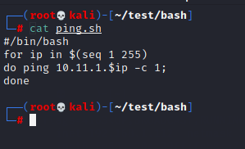

2. Try to do the above exercise with a higher-level scripting language such as Python, Perl, or

Ruby.

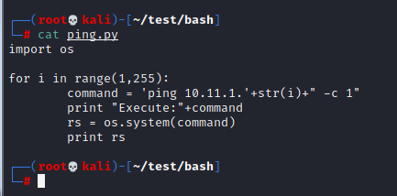

3. Use the practical examples in this module to help you create a Bash script that extracts

JavaScript files from the access_log.txt file (http://www.offensive-security.com/pwk-

files/access_log.txt.gz). Make sure the file names DO NOT include the path, are unique, and

are sorted.

command:

grep "\.js" access_log.txt|awk -F "HTTP" '{print $1}'|awk -F "include/" '{print $2}'|sort -u

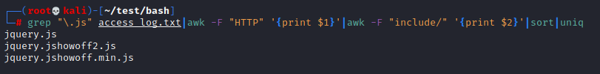

1. Re-write the previous exercise in another language such as Python, Perl, or Ruby.

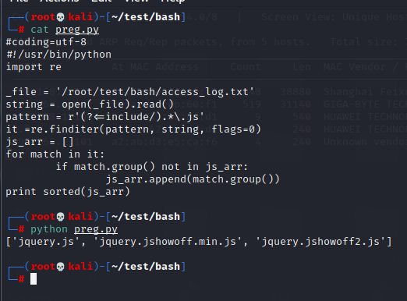

chapter 6

6.3.1.1 Exercise

1. Use the whois tool in Kali to identify the name servers of MegaCorp One.

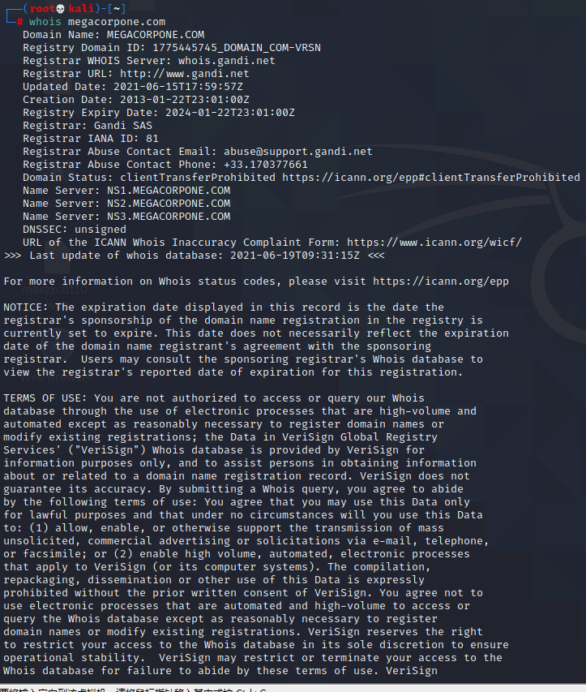

6.4.1.1 Exercises

1. Who is the VP of Legal for MegaCorp One and what is their email address?

#### **Name:Mike Carlow**

**Email:Email: mcarlow@megacorpone.com**

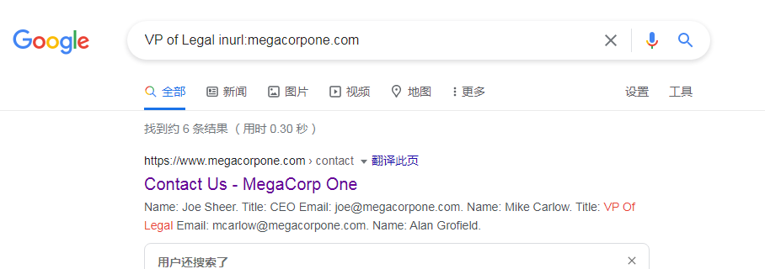

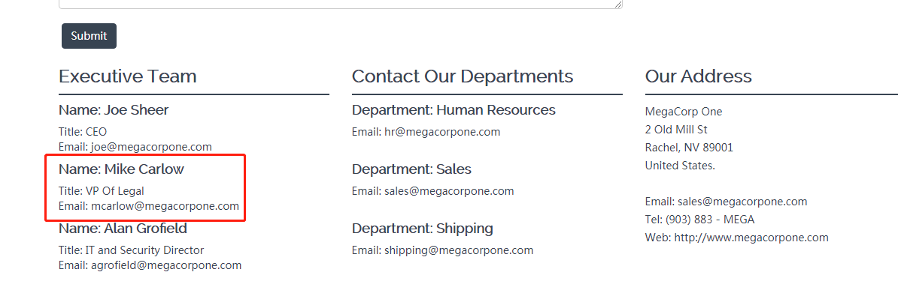

2. Use Google dorks (either your own or any from the GHDB) to search

www.megacorpone.com for interesting documents.





3. What other MegaCorp One employees can you identify that are not listed on

[www.megacorpone.com?](http://www.megacorpone.com?)

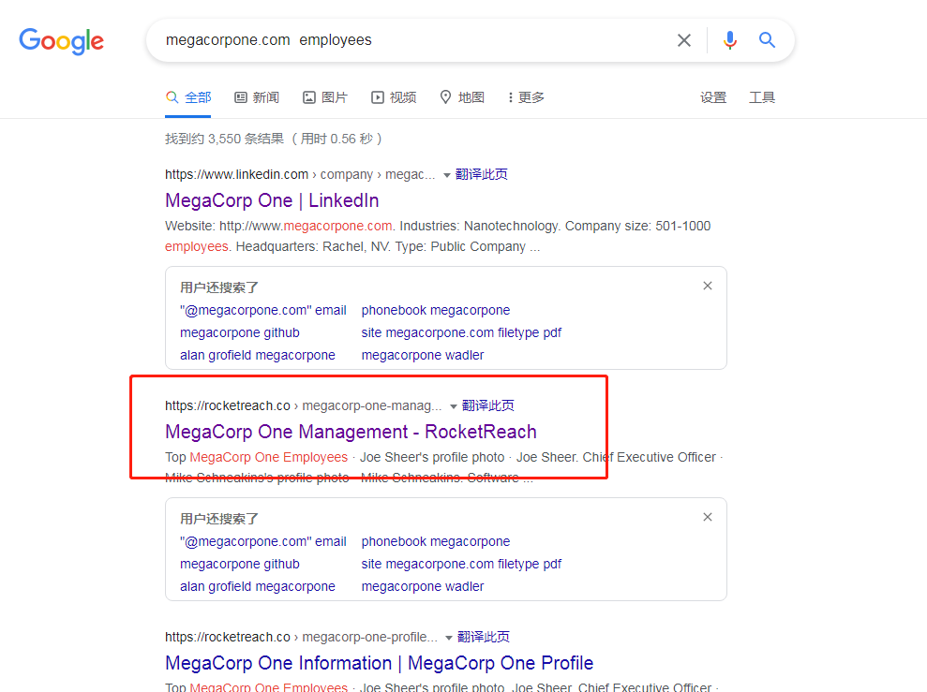

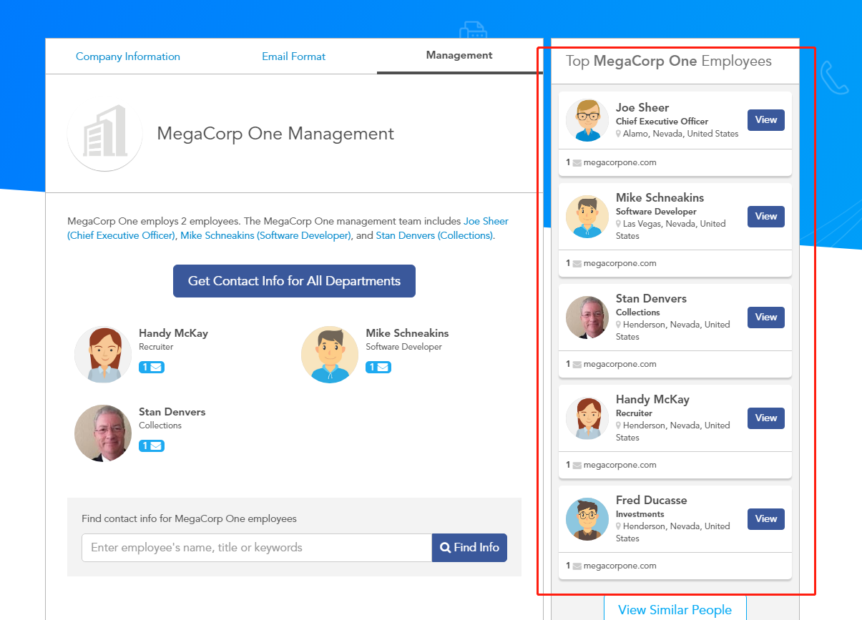

6.5.1.1 Exercise

1. Use Netcraft to determine what application server is running on www.megacorpone.com.

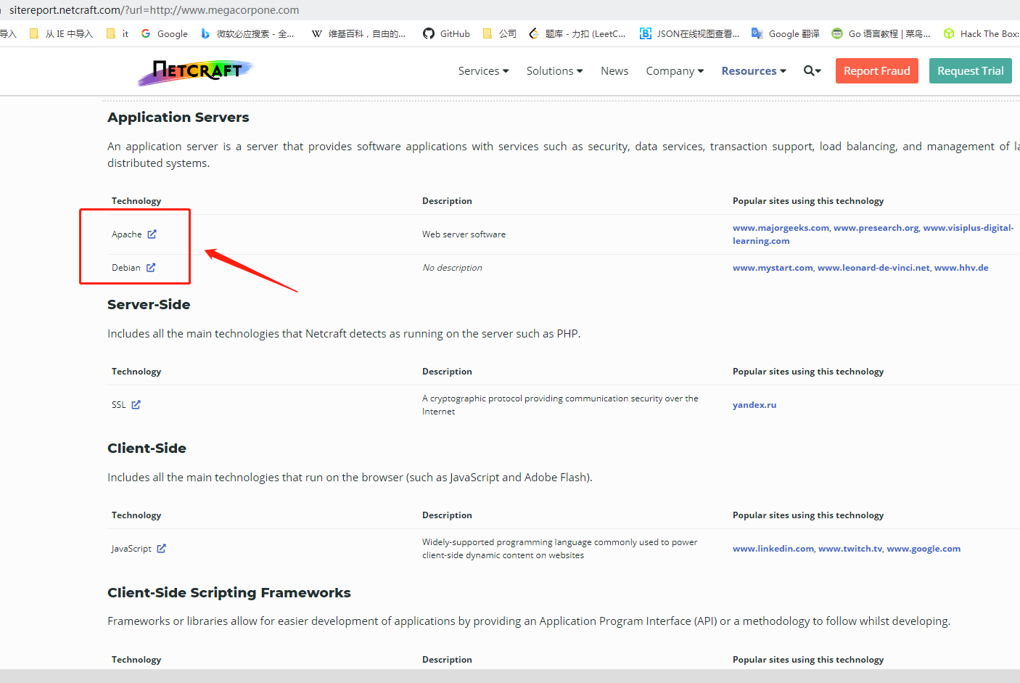

6.7.1.1 Exercise

1. Search Megacorpone’s GitHub repos for interesting or sensitive information.

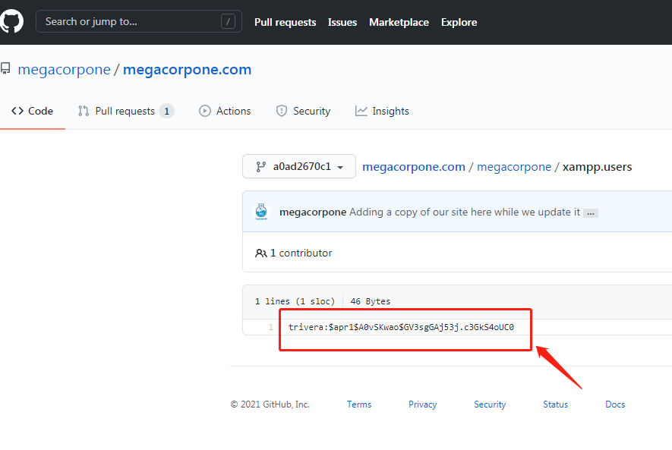

6.12.1.1 Exercises

1. Use theHarvester to enumerate emails addresses for megacorpone.com.

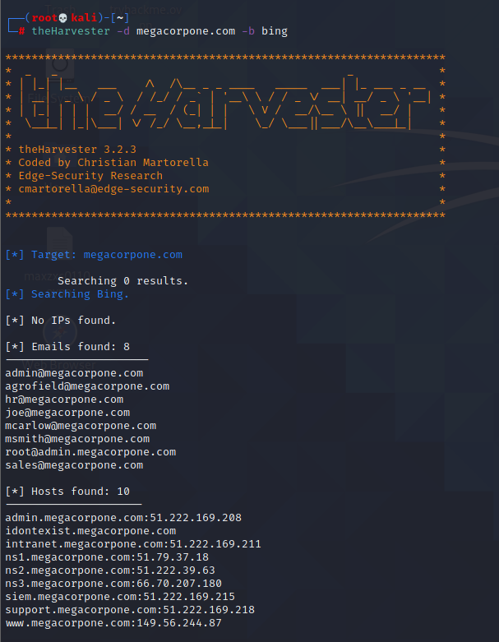

2. Experiment with different data sources (-b). Which ones work best for you?

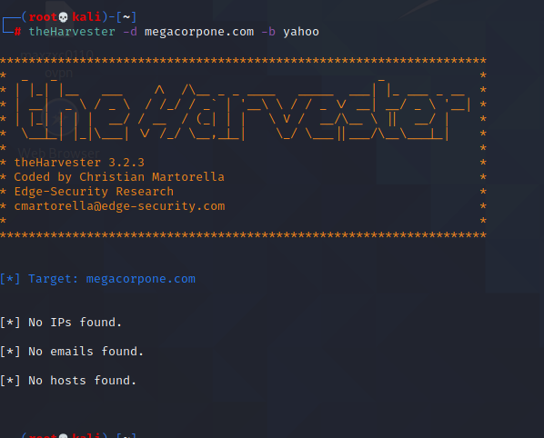

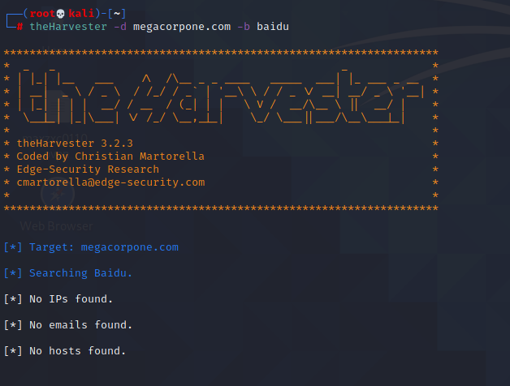

6.13.2.1 Exercise

1. Use any of the social media tools previously discussed to identify additional MegaCorp One

employees.

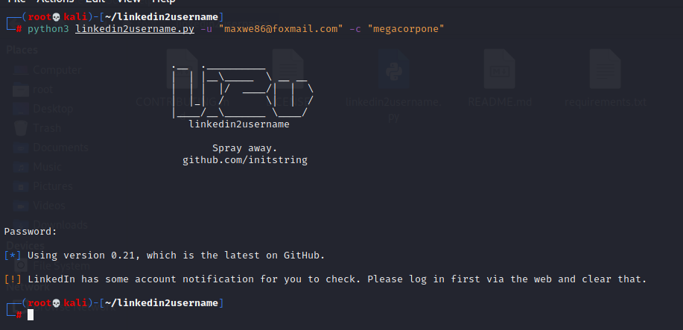

chapter 7

7.1.6.3 Exercises

1. Find the DNS servers for the megacorpone.com domain.

dnsenum megacorpone.com

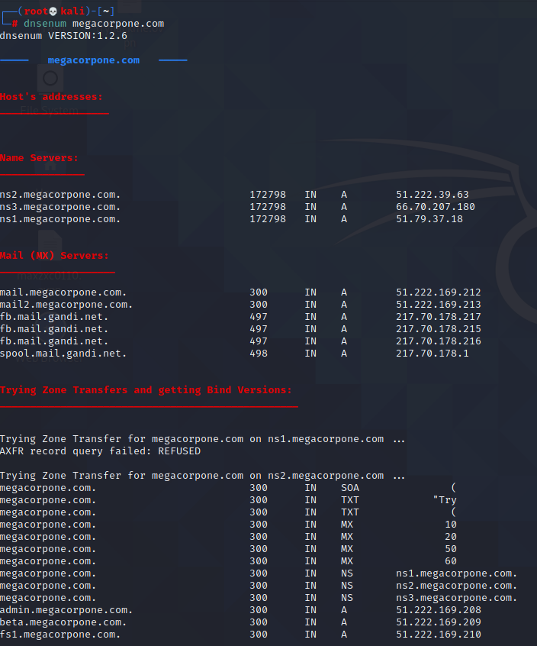

2. Write a small script to attempt a zone transfer from megacorpone.com using a higher-level

scripting language such as Python, Perl, or Ruby.

python2 source code

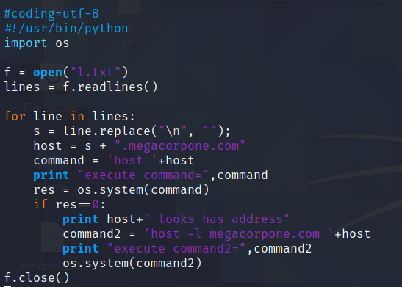

Execute:

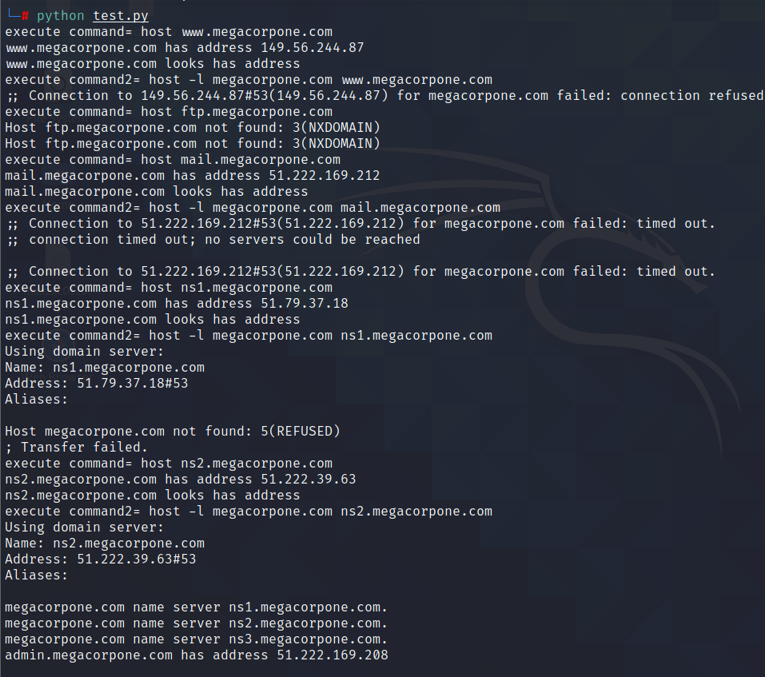

1. Recreate the example above and use dnsrecon to attempt a zone transfer from megacorpone.com.

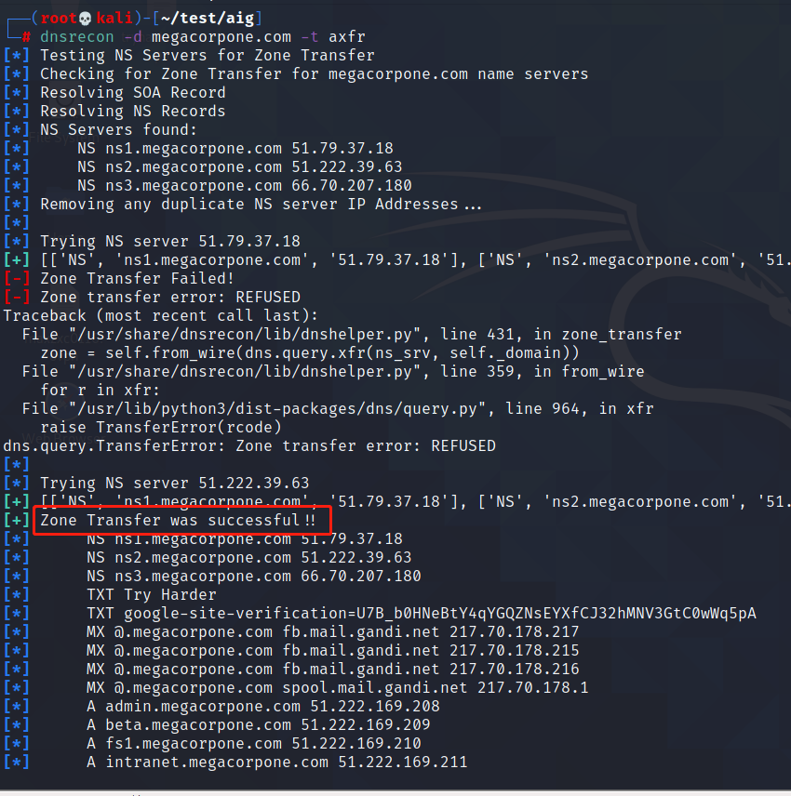

7.3.2.1 Exercises

1. Use Nmap to make a list of the SMB servers in the lab that are running Windows.

2. Use NSE scripts to scan these systems for SMB vulnerabilities.

3. Use nbtscan and enum4linux against these systems to identify the types of data you can

obtain from different versions of Windows.

7.4.2.1 Exercises

1. Use Nmap to make a list of machines running NFS in the labs.

2. Use NSE scripts to scan these systems and collect additional information about accessible

shares.

7.5.1.1 Exercises

1. Search your target network range to see if you can identify any systems that respond to the

SMTP VRFY command.

2. Try using this Python code to automate the process of username discovery using a text file

with usernames as input.

7.6.3.6 Exercises

1. Scan your target network with onesixtyone to identify any SNMP servers.

2. Use snmpwalk and snmp-check to gather information about the discovered targets.

chapter 8

8.2.4.2 Exercises

1. Follow the steps above to create your own unauthenticated scan of Gamma.

2. Run the scan with Wireshark open and identify the steps the scanner performed to

completed the scan.

1. Review the results of the scan.

8.2.5.2 Exercises

1. Follow the steps above to create your own authenticated scan of your Debian client.

2. Review the results of the scan.

8.2.6.1 Exercises

1. Follow the steps above to create your own individual scan of Beta.

2. Run Wireshark or tcpdump during the individual scan. What other ports does Nessus scan?

Why do you think Nessus scans other ports?

1. Review the results of the scan.

8.3.1.1 Exercise

1. Find an NSE script similar to the NFS Exported Share Information Disclosure that was

executed in the “Scanning with Individual Nessus Plugins” section. Once found, run the script

against Beta in the PWK labs.

chapter 9

9.3.4.1 Exercise

1. Spend some time reviewing the applications available under the Web Application Analysis menu in Kali Linux.

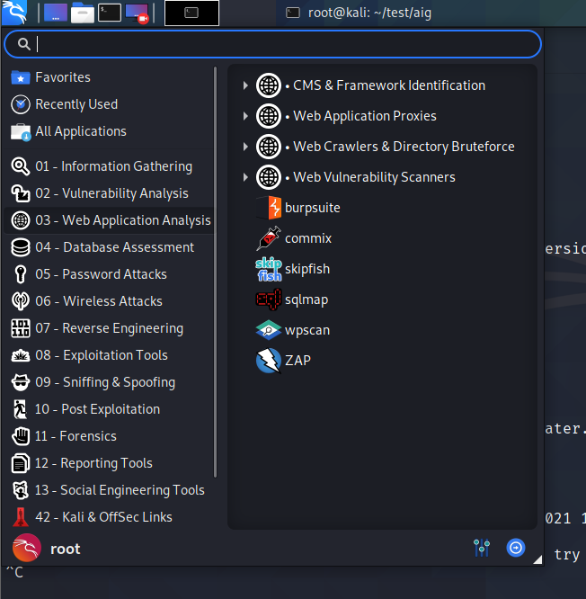

9.4.1.3 Exercises

1. Use Burp Intruder to gain access to the phpMyAdmin site running on your Windows 10 lab machine.

2. Insert a new user into the “users” table.

9.4.2.5 Exercises

1. Exploit the XSS vulnerability in the sample application to get the admin cookie and hijack the

session. Remember to use the PowerShell script on your Windows 10 lab machine to

simulate the admin login.

2. Consider what other ways an XSS vulnerability in this application might be used for attacks.

3. Does this exploit attack the server or clients of the site?

9.4.3.2 Exercise

1. Exploit the directory traversal vulnerability to read arbitrary files on your Windows 10 lab machine.

9.4.4.7 Exercises

1. Exploit the RFI vulnerability in the web application and get a shell.

2. Using /menu2.php?file=current_menu as a starting point, use RFI to get a shell.

3. Use one of the webshells included with Kali to get a shell on the Windows 10 target.

9.4.4.10 Exercises

1. Exploit the LFI vulnerability using a PHP wrapper.

2. Use a PHP wrapper to get a shell on your Windows 10 lab machine.

9.4.5.4 Exercises

1. Interact with the MariaDB database and manually execute the commands required to

authenticate to the application. Understand the vulnerability.

2. SQL inject the username field to bypass the login process.

3. Why is the username displayed like it is in the web application once the authentication

process is bypassed?

4. Execute the SQL injection in the password field. Is the “LIMIT 1” necessary in the payload?

Why or why not?

9.4.5.9 Exercises

1. Enumerate the structure of the database using SQL injection.

2. Understand how and why you can pull data from your injected commands and have it

displayed on the screen.

1. Extract all users and associated passwords from the database.

9.4.5.11 Exercises

1. Exploit the SQL injection along with the MariaDB INTO OUTFILE function to obtain code

execution.

1. Turn the simple code execution into a full shell.

9.4.5.13 Exercises

1. Use sqlmap to obtain a full dump of the database.

2. Use sqlmap to obtain an interactive shell.

chapter 10

10.2.5 Exercises

1. Repeat the steps shown in this section to see the 12 A’s copied onto the stack.

2. Supply at least 80 A’s and verify that EIP after the strcpy will contain the value 41414141.

chapter 11

11.1.1.2 Exercises

1. Build the fuzzer and replicate the SyncBreeze crash.

2. Inspect the content of other registers and stack memory. Does anything seem to be directly

influenced by the fuzzing input?

11.2.3.1 Exercises

1. Write a standalone script to replicate the crash.

2. Determine the offset within the input buffer to successfully control EIP.

3. Update your standalone script to place a unique value into EIP to ensure your offset is

correct.

11.2.5.1 Exercises

1. Repeat the required steps in order to identify the bad characters that cannot be included in

the payload.

1. Why are these characters not allowed? How do these bad hex characters translate to ASCII?

11.2.7.1 Exercises

1. Locate the JMP ESP that is usable in the exploit.

2. Update your PoC to include the discovered JMP ESP, set a breakpoint on it, and follow the

execution to the placeholder shellcode.

11.2.9.1 Exercises

1. Update your PoC to include a working payload.

2. Attempt to execute your exploit without using a NOP sled and observe the decoder

corrupting the stack.

1. Add a NOP sled to your PoC and obtain a shell from SyncBreeze.

11.2.10.1 Exercise

1. Update the exploit so that SyncBreeze still runs after exploitation

chapter 12

12.2.1.2 Exercises

1. Log in to your dedicated Linux client using the credentials you received.

2. On your Kali machine, recreate the proof-of-concept code that crashes the Crossfire server.

3. Attach the debugger to the Crossfire server, run the exploit against your Linux client, and

confirm that the EIP register is overwritten by the malicious buffer.

12.3.1.1 Exercises

1. Determine the correct buffer offset required to overwrite the return address on the stack.

2. Update your stand-alone script to ensure your offset is correct.

12.5.1.1 Exercises

1. Determine the opcodes required to generate a first stage shellcode using msf-nasm_shell.

2. Identify the bad characters that cannot be included in the payload and return address.

12.6.1.1 Exercises

1. Find a suitable assembly instruction address for the exploit using EDB.

2. Include the first stage shellcode and return address instruction in your proof-of-concept and

ensure that the first stage shellcode is working as expected by single stepping through it in

the debugger.

12.7.1.1 Exercises

1. Update your proof-of-concept to include a working payload.

2. Obtain a shell from the Crossfire application with and without a debugger.

chapter 13

13.3.2.1 Exercise

1. Use the PowerShell payload from the HTA attack to create a Word macro that sends a

reverse shell to your Kali system.

13.3.3.1 Exercise

1. Use the PowerShell payload to create a batch file and embed it in a Microsoft Word

document to send a reverse shell to your Kali system.

13.3.4.1 Exercises

1. Trigger the protection by Protected View by simulating a download of the Microsoft Word

document from the Internet.

2. Reuse the batch file and embed it in a Microsoft Publisher document to receive a reverse

shell to your Kali system.

3. Move the file to the Apache web server to simulate the download of the Publisher document

from the Internet and confirm the missing Protected View.

chapter 14

14.3.1.1 Exercises

1. Connect to your dedicated Linux client and start the vulnerable Apache James service using

the /usr/local/james/bin/run.sh script.

2. Enumerate the target using port scanning utilities and use information from the banners and

Internet searches to determine the software running on the machine.

3. Use the searchsploit tool to find exploits for this version on the online resources mentioned

in this module.

4. Launch the exploit and verify that the payload is executed upon logging in to the machine.

5. Attempt to modify the payload variable in order to get a reverse shell on the target machine.

chapter 15

15.1.3.1 Exercises

1. Locate the exploit discussed in this section using the searchsploit tool in Kali Linux.

2. Install the mingw-w64 suite in Kali Linux and compile the exploit code

15.1.4.1 Exercises

1. Modify the connection information in the exploit in order to target the SyncBreeze

installation on your Windows client.

2. Recompile the exploit and use Wireshark to confirm that the code successfully initiates a

socket connection to your dedicated Windows client.

15.1.5.1 Exercise

1. Find any valid return address instruction and alter the one present in the original exploit.

15.1.6.1 Exercises

1. Generate a reverse shell payload using msfvenom while taking into account the bad

characters of our exploit.

2. Replace the original payload with the newly generated one.

3. Attach the debugger to the target process and set a breakpoint at the return address

instruction.

1. Compile the exploit and run it. Did you hit the breakpoint?

15.1.7.1 Exercises

1. Fix the overflow buffer such that the EIP register will be overwritten by your chosen return

address instruction.

2. Install the ASX to MP3 Converter application located under the C:\ \ Tools\ \ fixing_exploits

directory; download the exploit for ASX to MP3 Converter from EDB 391 and edit it in order to

get a shell on your dedicated Windows machine.

15.2.3.1 Exercises

1. Connect to your dedicated Linux lab client and start the apache2 service; the target web

application is located under /var/www/https/ .

2. Modify the original exploit and set the base_url variable to the correct IP address of your

dedicated Linux lab client as well as the protocol to HTTPS.

3. Get familiar with the requests Python library and adjust your exploit accordingly to avoid SSL

verification.

4. Edit the username and password variables to match the ones from our test case (username

“admin”, password “HUYfaw763”).

1. Try to run the exploit against the Linux lab client, does it work? If not, try to explain why

15.2.4.1 Exercises

1. Observe the error that is generated when running the exploit.

2. Attempt to troubleshoot the code and determine why the error occurs.

3. Modify the exploit in order to avoid the error and run it against your dedicated Linux client.

4. Verify that your exploit worked by attempting to execute the whoami command using the

remote php shell.

5. Attempt to obtain a fully interactive shell with this exploit.

chapter 16

本章没有习题

chapter 17

17.3.3.2 Exercises

1. Review the code from the PowerShell script and ensure that you have a basic understanding

of how it works.

2. Get a meterpreter shell back to your Kali Linux machine using PowerShell.

3. Attempt to get a reverse shell using a PowerShell one-liner rather than a script.

17.3.3.4 Exercises

1. Inject a meterpreter reverse shell payload in the WinRAR executable.

2. Transfer the binary to your Windows client and ensure that it is not being detected by the

antivirus.

3. Run the WinRAR installer and migrate your meterpreter shell to prevent a disconnect.

4. Attempt to find different executables and inject malicious code into them using Shellter.

chapter 18

18.1.1.13 Exercise

1. Perform various manual enumeration methods covered in this section on both your

dedicated Windows and Linux clients. Try experimenting with various options for the tools

and commands used in this section.

18.1.2.1 Exercises

1. Inspect your Windows and Linux clients by using the tools and commands presented in this

section in order to get comfortable with manual local enumeration techniques.

1. Experiment with different windows-privesc-check and unix_privesc_check options.

18.2.3.2 Exercise

1. Log in to your Windows client as the admin user and attempt to bypass UAC using the

application and technique covered above.

18.2.4.1 Exercises

1. Log in to your Windows client as an unprivileged user and attempt to elevate your privileges

to SYSTEM using the above vulnerability and technique.

1. Attempt to get a remote system shell rather than adding a malicious user.

18.3.2.1 Exercise

1. Log in to your Debian client as an unprivileged user and attempt to elevate your privileges to

root using the above technique.

18.3.3.1 Exercise

1. Log in to your Debian client with your student credentials and attempt to elevate your

privileges by adding a superuser account to the /etc/passwd file.

chapter 19

19.4.2.1 Exercises

1. Use Mimikatz to extract the password hash of an administrative user from the Windows

client.

2. Reuse the password hash to perform a pass-the-hash attack from your Kali system and

obtain code execution on your Windows client.

chapter 20

20.2.1.1 Exercises

1. Connect to your dedicated Linux lab client and run the clear_rules.sh script from

/root/port_forwarding_and_tunneling/ as root.

2. Run the ssh_local_port_forwarding.sh script from /root/port_forwarding_and_tunneling/ as

root.

3. Take note of the Linux client and Windows Server 2016 IP addresses shown in the Student

Control Panel.

1. Attempt to replicate the smbclient enumeration covered in the above scenario.

20.2.2.2 Exercises

1. Connect to your dedicated Linux lab client via SSH and run the clear_rules.sh script from

/root/port_forwarding_and_tunneling/ as root.

2. Close any SSH connections to your dedicated Linux lab client and then connect as the

student account using rdesktop and run the ssh_remote_port_forward.sh script from

/root/port_forwarding_and_tunn eling/ as root.

3. Attempt to replicate the SSH remote port forwarding covered in the above scenario and

ensure that you can scan and interact with the MySQL service.

20.2.3.1 Exercises

1. Connect to your dedicated Linux lab client and run the clear_rules.sh script from

/root/port_forwarding_and_tunneling/ as root.

2. Take note of the Linux client and Windows Server 2016 IP addresses.

3. Create a SOCKS4 proxy on your Kali machine, tunneling through the Linux target.

4. Perform a successful nmap scan against the Windows Server 2016 machine through the

proxy.

5. Perform an nmap SYN scan through the tunnel. Does it work? Are the results accurate?

20.3.1.1 Exercises

1. Obtain a reverse shell on your Windows lab client through the Sync Breeze vulnerability.

2. Use plink.exe to establish a remote port forward to the MySQL service on your Windows 10

client.

1. Scan the MySQL port via the remote port forward.

20.4.1.1 Exercise

1. Obtain a reverse shell on your Windows lab client through the Sync Breeze vulnerability.

2. Using the SYSTEM shell, attempt to replicate the port forwarding example using netsh.

20.5.1.1 Exercises

1. Connect to your dedicated Linux lab client as the student account using rdesktop and run the

http_tunneling.sh script from /root/port_forwarding_and_tunneling/ as root.

2. Start the apache2 service and exploit the vulnerable web application hosted on port 443

(covered in a previous module) in order to get a reverse HTTP shell. 599

3. Replicate the scenario demonstrated above using your dedicated clients.

chapter 21

待补充

chapter 22

22.1.3.1 Exercises

1. Start the postgresql service and launch msfconsole.

2. Use the SMB, HTTP, and any other interesting auxiliary modules to scan the lab systems.

3. Review the hosts’ information in the database.

22.3.7.1 Exercises

1. Create a staged and a non-staged Linux binary payload to use on your Kali system.

2. Setup a Netcat listener and run the non-staged payload. Does it work?

3. Setup a Netcat listener and run the staged payload. Does it work?

4. Get a Meterpreter shell on your Windows system. Practice file transfers.

5. Inject a payload into plink.exe . Test it on your Windows system.

6. Create an executable file running a Meterpreter payload and execute it on your Windows

system.

1. After establishing a Meterpreter connection, setup a new transport type and change to it.

22.5.4.1 Exercise

1. Use post-exploitation modules and extensions along with pivoting techniques to enumerate

and compromise the domain controller from a meterpreter shell obtained from your

Windows 10 client.

22.6.1.1 Exercise

1. Create a resource script using both a second stage encoder and autorun scripts and use it

with the meterpreter payload.

chapter 23

23.1.3.1 Exercises

Now that we’ve walked through the basic features of PowerShell Empire, try these exercises on

your own to solidify your knowledge.

1. Install and start PowerShell Empire on your Kali system.

2. Create a PowerShell Empire listener on your Kali machine and execute a stager on your

Windows 10 client.

3. Experiment with the PowerShell Empire agent and its basic functionality.

23.3.1.1 Exercises

1. Set up a PowerShell Empire listener and stager and obtain a working agent.

2. Perform enumeration on the domain using various modules.

3. Perform a remote desktop login with the account Jeff_Admin to ensure the credentials are

cached on the Windows 10 client and then dump the credentials using PowerShell Empire.

1. Experiment with the different lateral movement modules.